Assignment 7=>Upload a static website to the EC2 server

1. 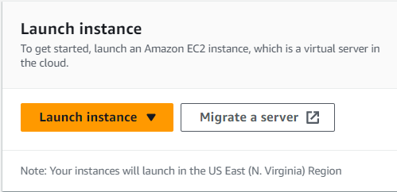At first Search EC2 then click **launch instance.**
2. Then give a unique name to your server. Then go down and choose ubuntu(free) as the operating system.

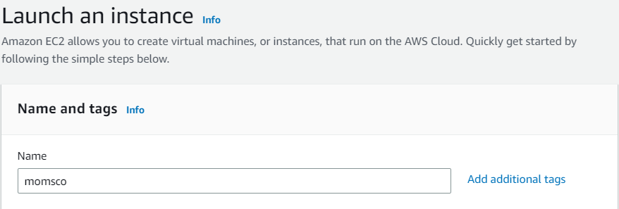

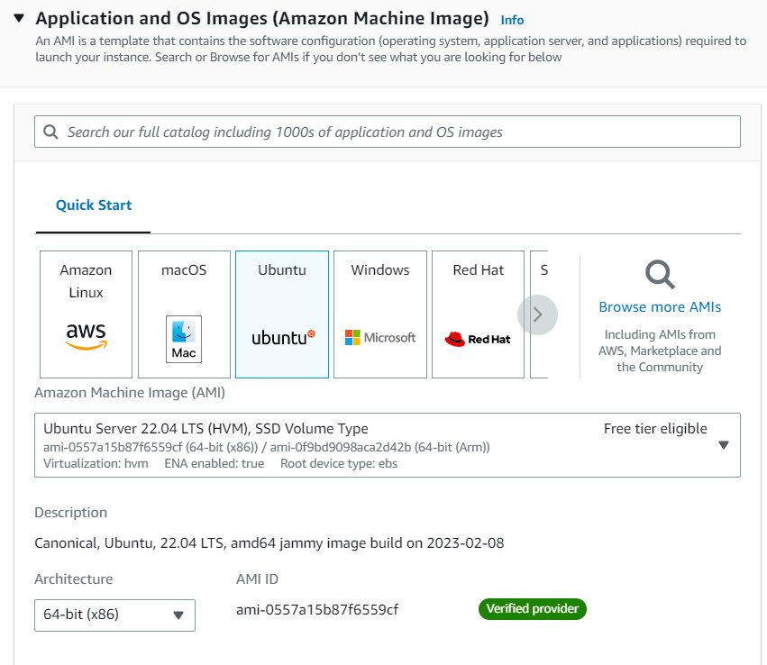

1. 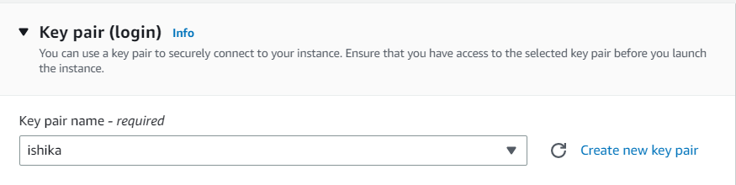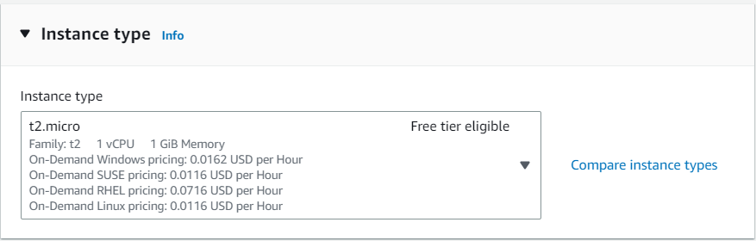Select instance type t2.micro then add key pair.
2. 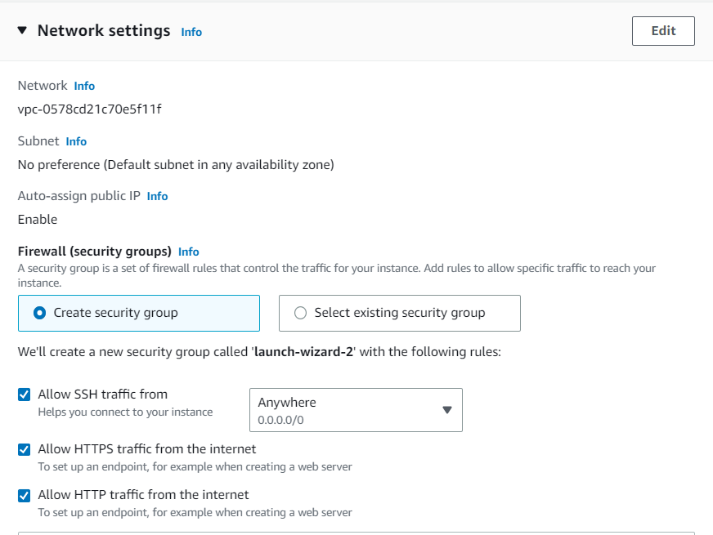In network settings check all the SSH, HTTP, and HTTPS.
3. 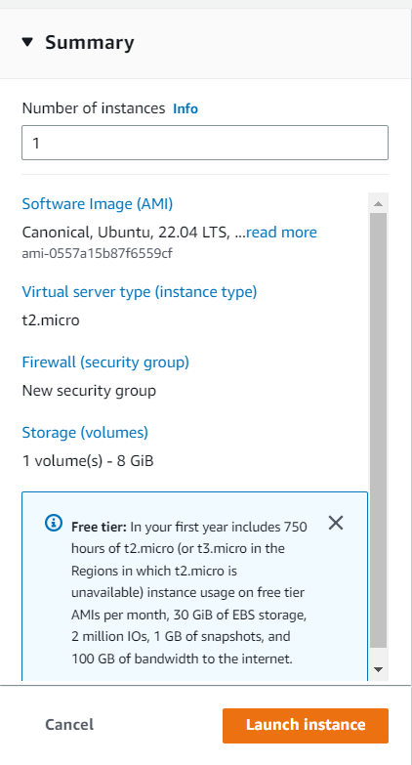Then click **launch instance**.
4. 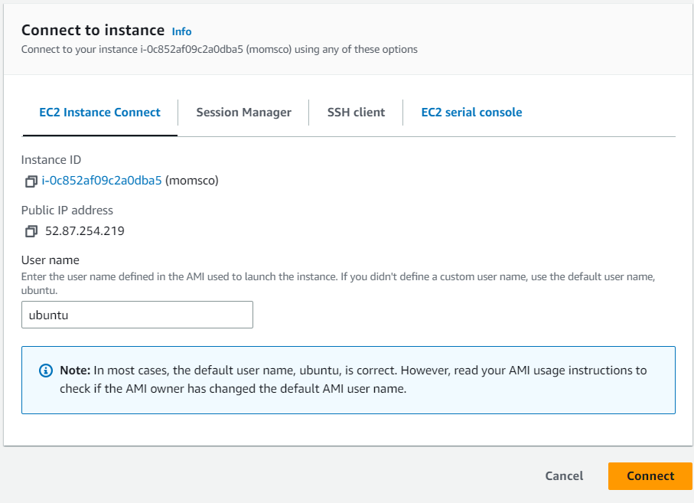Select the instance you created the instance status should be **Running** then click **connect** then give the username ubuntu and click **connect**.
5. 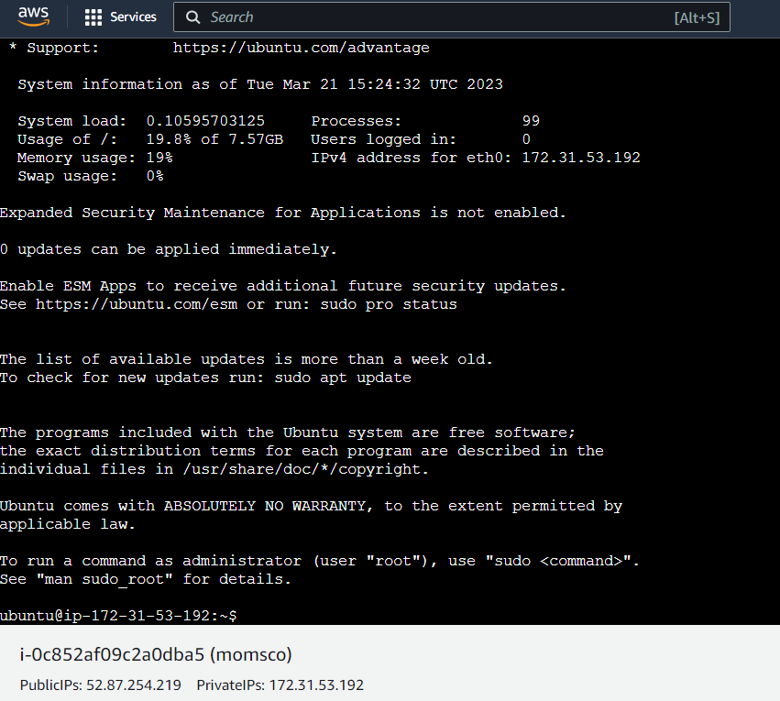Then the OS will start in a new tab.

1. 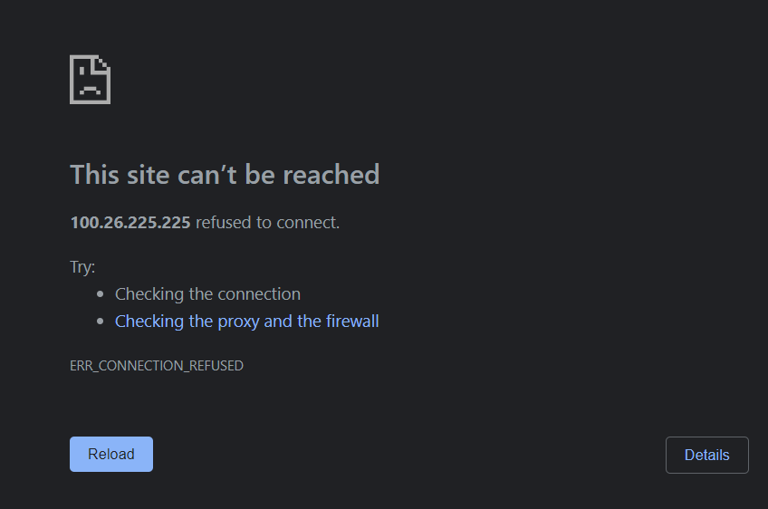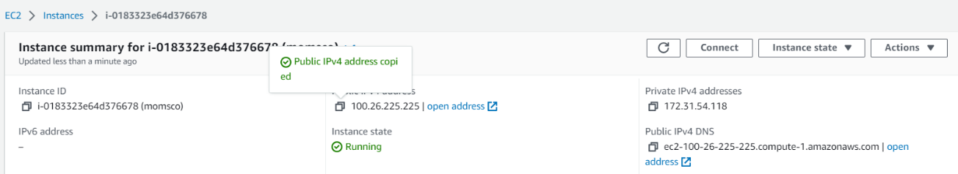Go into the instance then copy the **Public IPv4 address** and paste it into the browser it will show **This site cannot be reached.**
2. Open **Bitvise SSH Client** on your computer. and paste the copied address into the **host** field.
3. 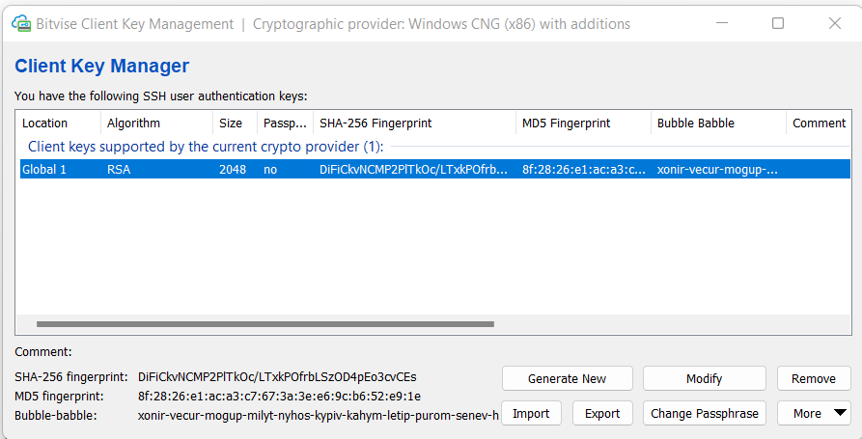Then click on the **Client key manager**. Then there click **import.** And import the .pem file that contains the key. The client key will appear there**. Then go back.**
4. 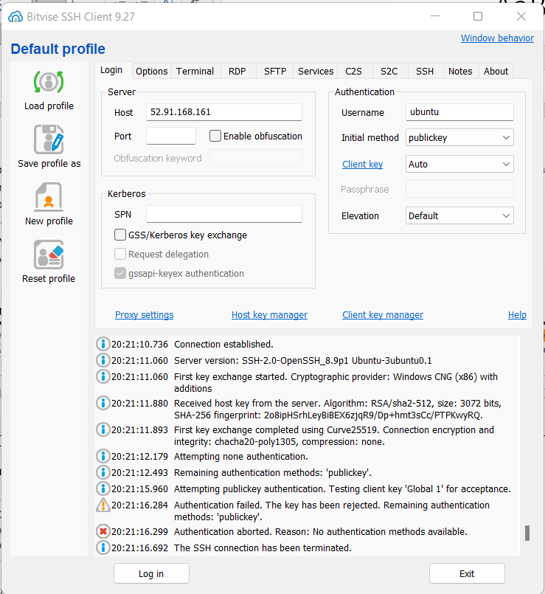Give the username **ubuntu** and select the initial method **publickey.** And click **log in.**
5. 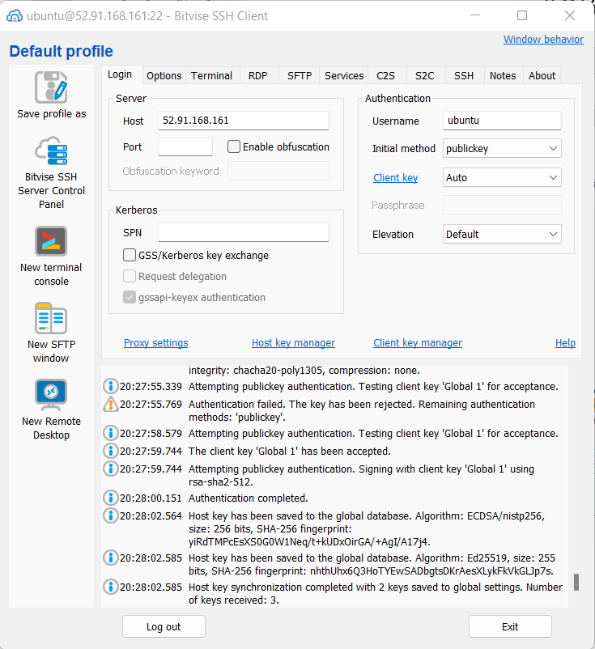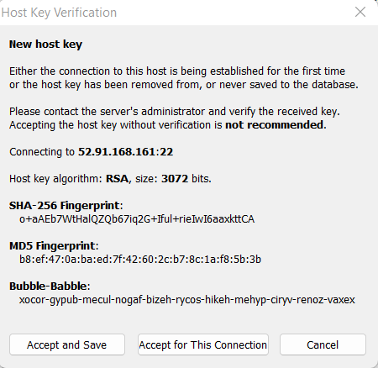Then one **Host key verification** window will appear click **Accept and save**. And you will be logged in successfully.
6. Then click on a new terminal and one terminal will be opened.
7. There run the command **“sudo apt-get update” and** then run “**sudo apt-get upgrade**”.
8. 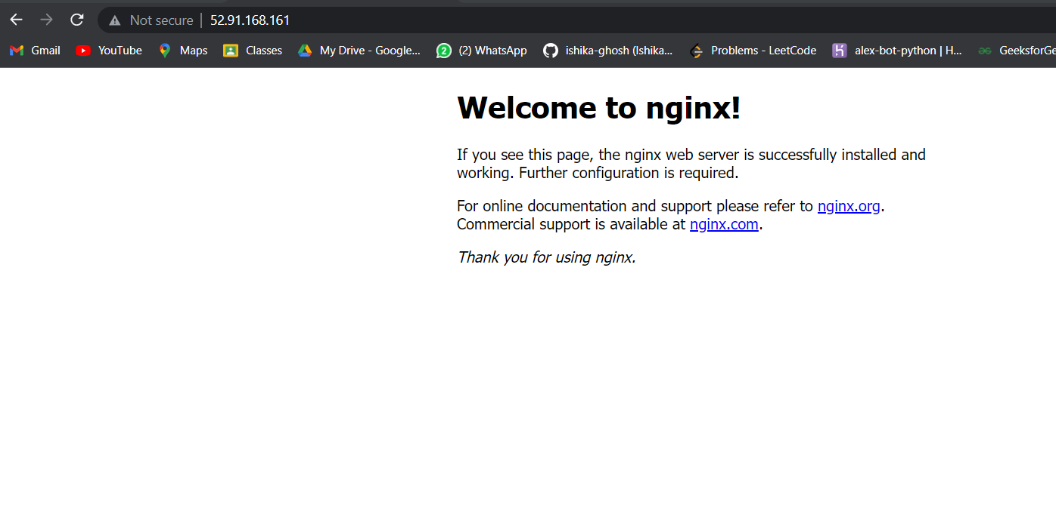After the run the command to install **nginx “sudo apt-get install nginx”. And refresh the browser.**
9. 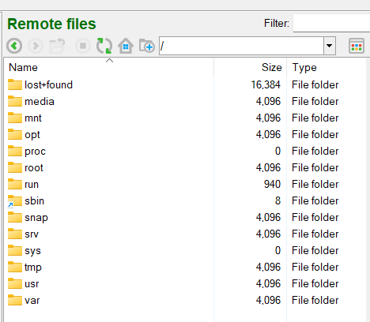Again go to Bitvise SSH Client and click **New SFTP Window.** In the remote files section go to the root directory. Go to **var** then go to **www.** Then go to **html.** Now again come to terminal to give the permission.

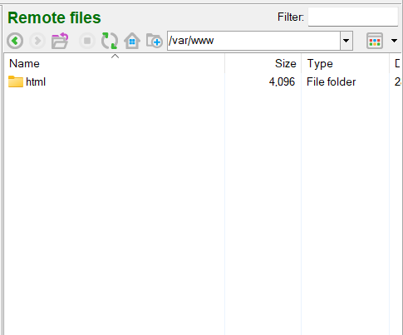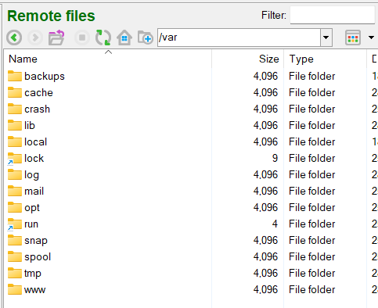

1. 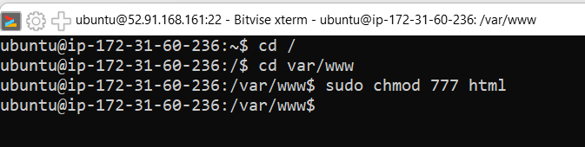Then go the **var/www** directory and run “**sudo chmod 777 html**”.
2. 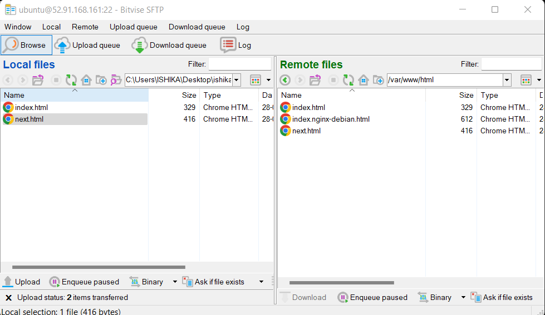Now again go to **SFTP** window and copy the local files in the previous folder.
3. 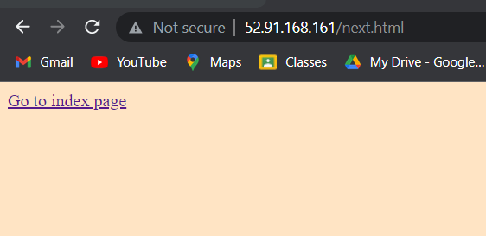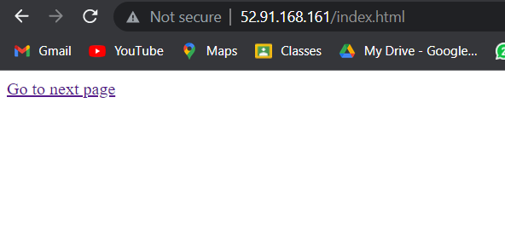Now refresh the browser. You will see those html pages coming.
4. 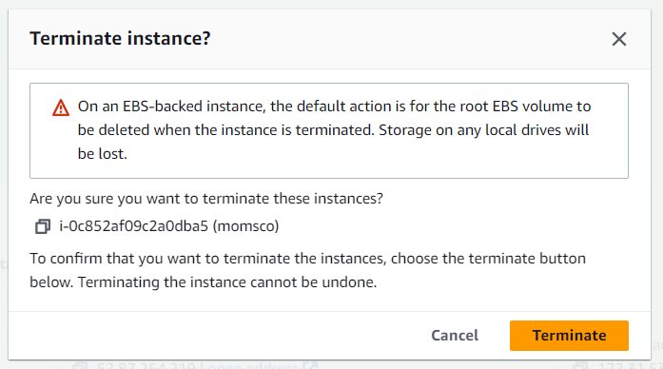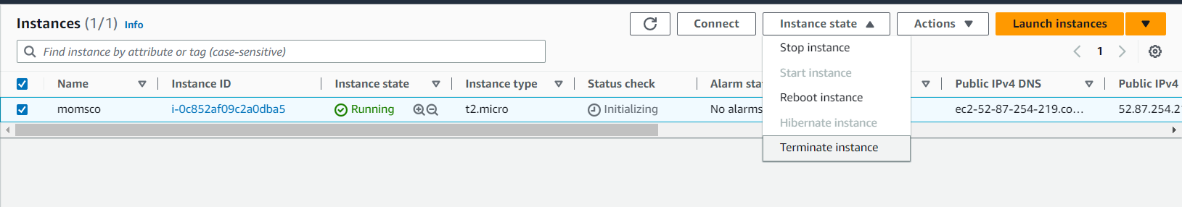After that select instance and terminate it otherwise It will cost money.

